**Agular Reactive Form with Form Array**

#1. Template Driven Form

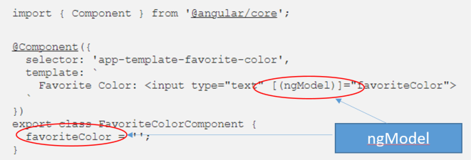

#2. Model Driven Form (Reactive Form)

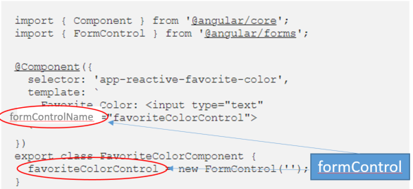

#3. Advantage of the Reactive Form

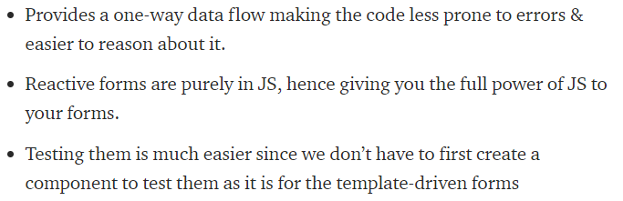

* Cleaner layout, better error visibility

#4. The Reactive Form with form array in action

1. Data display form array with the form fields, such as input, select, checkbox, etc.

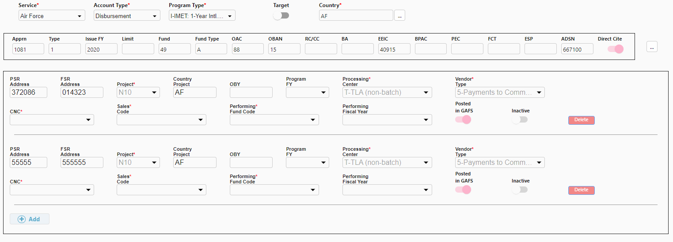

1. Add/Delete the form array with the event methods, such add, delete

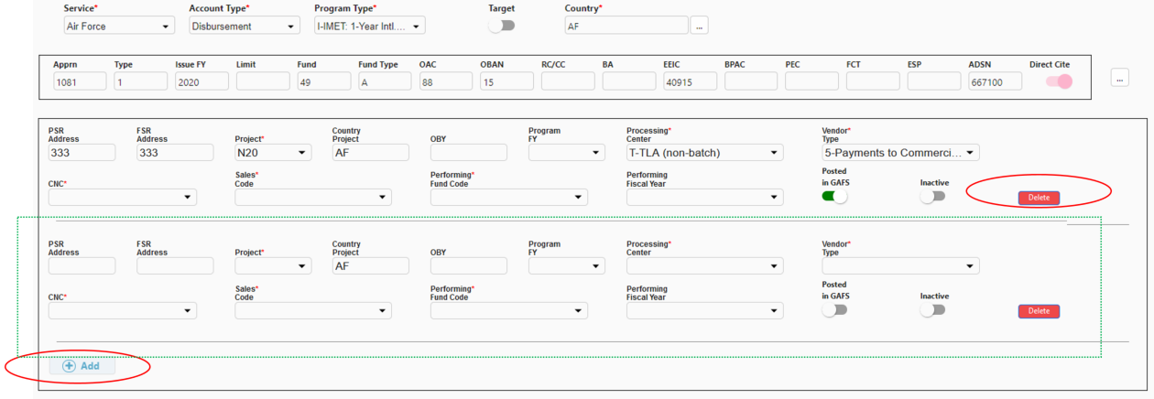

1. Mat-table, data display

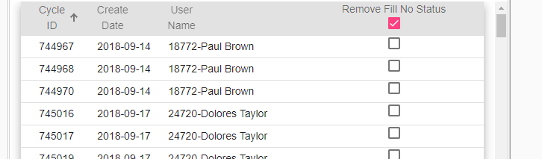

#5. Source code snapshot

1. Initial the Form Array

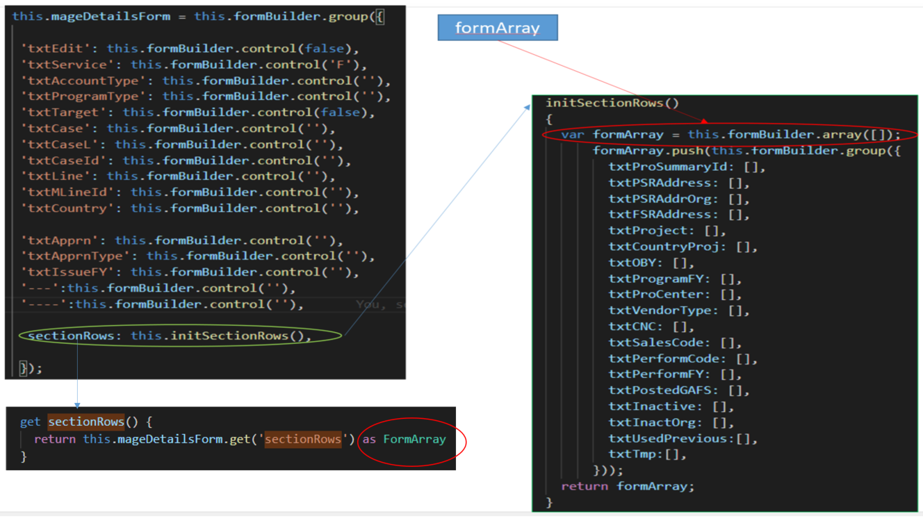

1. Patch/Display data to From Array in TS

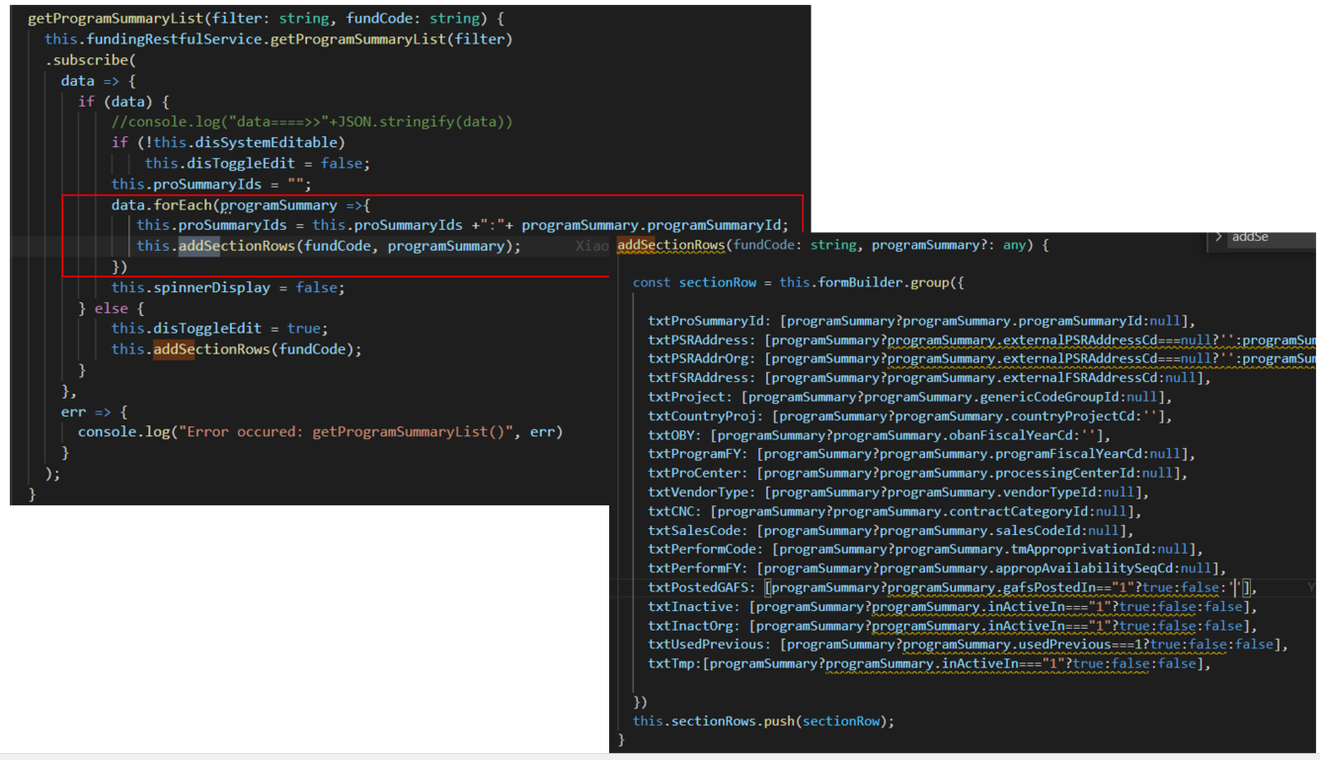

1. Patch/Display data to From Array in HTML

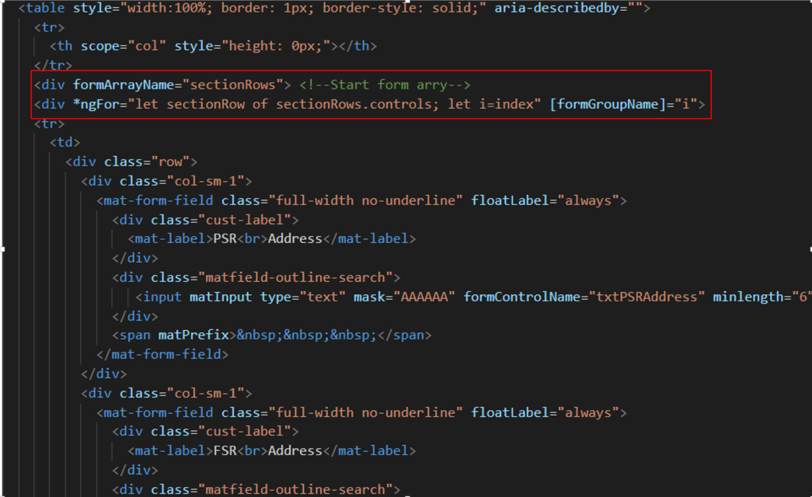

1. Reactive Form with FormArray submit value in JSON format

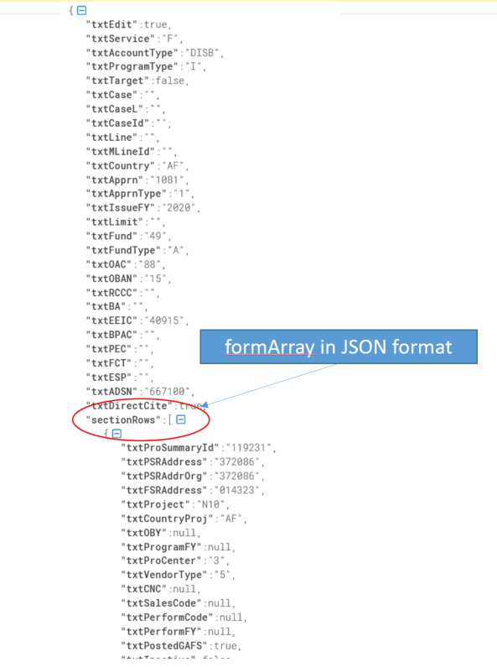

1. Angular Component Junit Test (Pseudo)

